Student Name: _________________________________ Date: ___________

Instructor Signature:_________________________________ Date: ___________

Point Assignment: ________________________


Purpose: The purpose of this laboratory experiment is to familiarize the student with single-phase transformer circuits. The student will compute and measure the voltage and current in transformer circuits. The student will compute and measure the transformer turns ratio and perform a variety of transformer tests to understand the operating properties of a transformer.

Background: One of the most fundamental components of a power system is the transformer. The transformer is used to step up and step down voltage levels to meet the needs of generation, transmission, and distribution systems. The transformer performs these operations based on the principle of magnetic induction.

A transformer is constructed of two conductors wrapped around a common iron core. The conductors are called windings and are designated as primary and secondary. The primary winding is the winding connected to the source, whereas the secondary winding is the winding connected to the load. As current flows through the primary winding, a magnetic field is established that conducts through the iron core linking the secondary winding to the same magnetic flux. This magnetic flux will induce a voltage in the secondary winding, proportional to the number of turns in the secondary winding. The most fundamental relationship for the transformer is the primary to secondary turns ratio, which is equal to the primary to secondary voltage ratio: 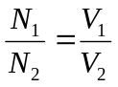

The performance characteristics of a transformer are generally determined by a series of tests. The open circuit and short circuit tests provide data for computing the transformer impedance, turns ratio, and other modeling parameters of the transformer. A core saturation test reveals the transformers iron core limitations when an over-voltage condition occurs. In some transformer applications, the transformer is used to buck or boost the input voltage. This type of application requires an understanding of the transformer polarity. A polarity test will reveal whether the magnetic flux is additive or subtractive. Typically, a dot is placed at the transformer terminals to indicate polarity.

Procedure: 1. Using an ohmmeter and a single phase transformer, measure the DC resistance of the primary and secondary winding.

Table #1

Transformer  Winding | DC Resistance (Ω)
Primary #1-2 | 8.60 ohms
Secondary #3-4 | 28.4 ohms
Secondary #3-7 | 13.4 ohms
Secondary #7-8 | 10.6 ohms
Secondary #8-4 | 4.60 ohms
Secondary #5-6 | 9.00 ohms
Secondary #5-9 | 4.30 ohms
Secondary #9-6 | 4.80 ohms

Open Circuit Test:
2. Build the circuit shown in figure #1 with the output unloaded.
Connect a voltmeter across the input and output terminals. Increase the input supply to 120V_{RMS}. Measure and record the primary voltage and the secondary voltage.

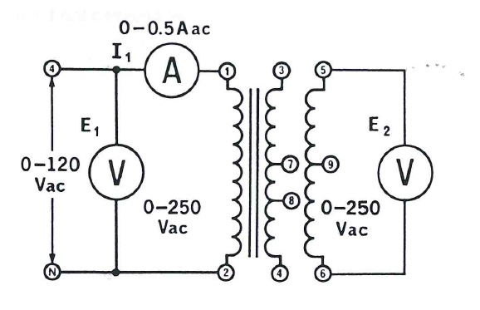
Figure #1

Table #2
Transformer  Winding | Measured  Voltage
1-2 | 120 V
3-4 | 205 V
5-6 | 120 V
3-7 | 100 V
7-8 | 75.0 V
8-4 | 28.0 V
5-9 | 60.0 V
9-6 | 60.0 V

3. Windings 1 to 2 and 5 to 6 each have 500 turns of wire. Winding 3 to 4 has 865 turns. Calculate the turns ratio as follows:

Table #3
Transformer  Winding | Turns  Ratio
1-2 to 5-6 | 1
3-4 to 1-2 | 1.71

Short Circuit Test

4. CAUTION: Set the input power supply to 0V before performing this test. Build the circuit shown in figure #2 with the output short circuited. Increase the input supply until the primary current reads 0.4A. Measure and record the primary voltage and current and the secondary current. Compute the transformer primary impedance (Vp/Ip) and the secondary to primary current ratio (I₂/I₁).

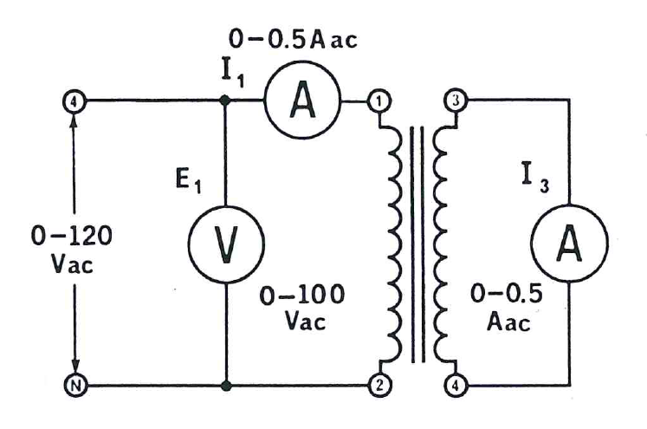

Figure #2 Short Circuit Test

Table #4
 | Measured  Voltage | Measured  Current | Calculated  Impedance | Calculated  I₂/I₁
Primary | 8.00 V | 400 mA | 20 ohms | 0.575
Secondary | 4.23 V | 230 mA

Saturation Test
5. Construct the circuit shown in figure #3. Connect the input to a variable power supply set for 0V. Turn on the power supply and measure and record the exciting current and secondary voltage. Increment the voltage in 25V_{RMS} increments and perform the same measurements. Record the measurements. Using an EXCEL spreadsheet plot the recorded input voltage versus current. Also, plot the recorded output voltage versus the input voltage.
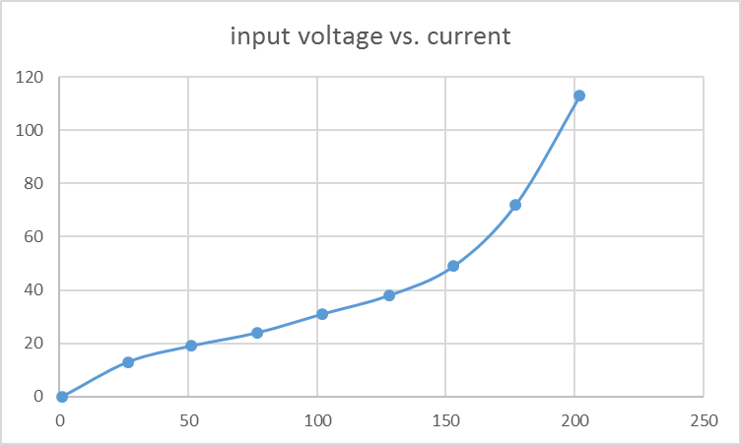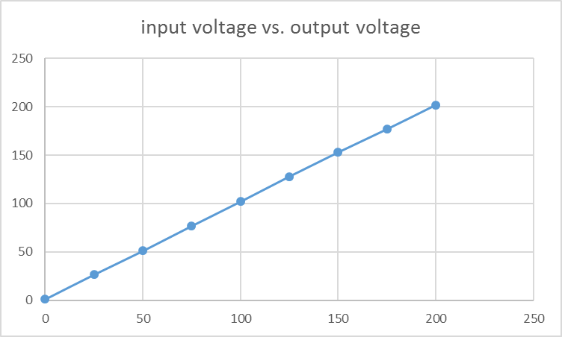

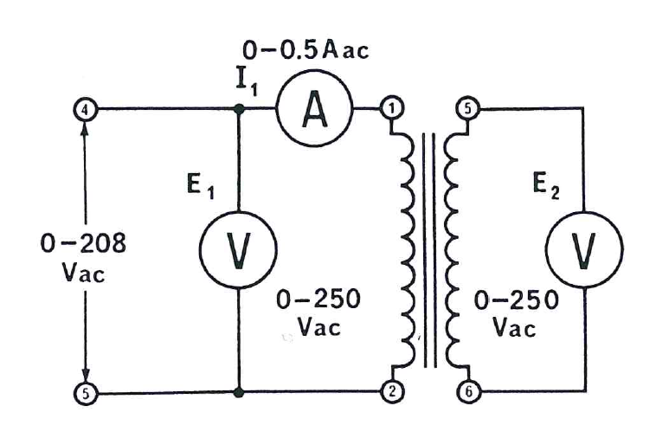
Figure #3: Saturation Test Connection Diagram

Table #5
Input  Voltage | Input  Current | Output  Voltage
0V | 0.00 | 992 mV
25V | 13.0 mA | 26.5V
50V | 19.0 mA | 51.0 V
75V | 24.0 mA | 76.8 V
100V | 31.0 mA | 102 V
125V | 38.0 mA | 128 V
150V | 49.0 mA | 153 V
175V | 72.0 mA | 177 V
200V | 113 mA | 202 V
Polarity Test:
6. For the autotransformer circuits shown in figures #4 and 5, the
input voltage is 104V, and the output voltage between terminals 1-
2 is 60V and 5-6 is 60V. Calculate the output voltage for each connection.
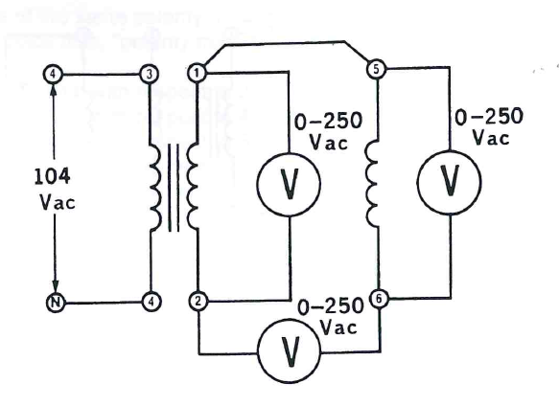
Figure #4 - Subtractive Polarity
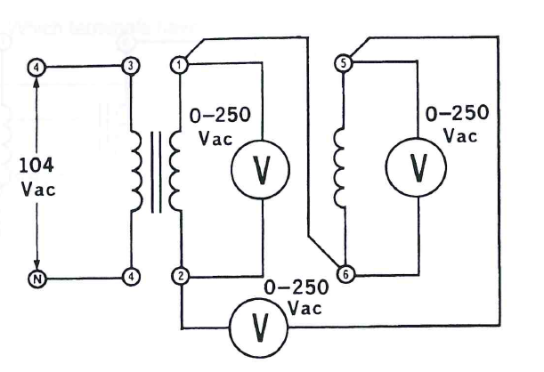
Figure #5 – Additive Polarity

Table #6
Transformer | Calculated Voltage (V)
Figure #4 | 0 V
Figure #5 | 120 V

7. Using a variable AC power supply and a single-phase transformer, construct the circuits in figures #4 and 5. Set the input voltage to 104V_{RMS}. Measure and record the output voltage.

Table #7
Transformer | Measured  Input Voltage | Measured  Output Voltage
Figure #4 | 104 V | 16.6 mV
Figure #5 | 104 V | 123 V

Distribution Transformer
8. For the circuit shown in Figure #6, the transformer is a step-down
center tapped transformer. The primary voltage is 208V and the secondary is 120V per leg (1-2 and 5-6) or 240V across 2-5. Calculate the secondary current flow through the 300Ω load resistors R₁ and R₂. Calculate the neutral current.

Table #8
Transformer | Calculated  Current
300Ω Load R₁ | 400 mA
300Ω Load R₂ | 400 mA
Secondary Neutral | 0

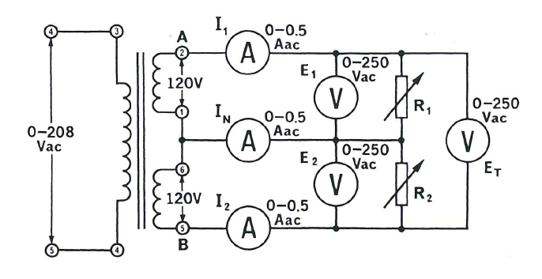
Figure #6

9. Replace R₁ of Figure #6 with a 600Ω resistor and perform the same calculations as listed in step #8.

Table #9
Transformer | Calculated  Current
600Ω Load R₁ | 200 mA
300Ω Load R₂ | 400 mA
Secondary Neutral | 200 mA

10. Construct the circuit of figure #6 using a variable AC power supply set for 208VAC across terminals 3-4. Measure the
secondary voltage and current, including the neutral current.

Table #10
 | Measured  Voltage | Measured  Current
Primary | 208 V
Load R₁ = 300Ω | 108 V | 372 mA
Load R₂ = 300Ω | 108 V | 370 mA
Neutral |  | 0 A

- Using the same circuit diagram of figure #6, replace the 300Ω resistor of R₁ with a 600Ω resistor. Perform the same measurements as step #10.

Table #11
 | Measured  Voltage | Measured  Current
Primary | 208V
R₁ = 600Ω | 110 V | 192 mA
R₂ = 300Ω | 110 V | 370 mA
Neutral |  | 180 mA

